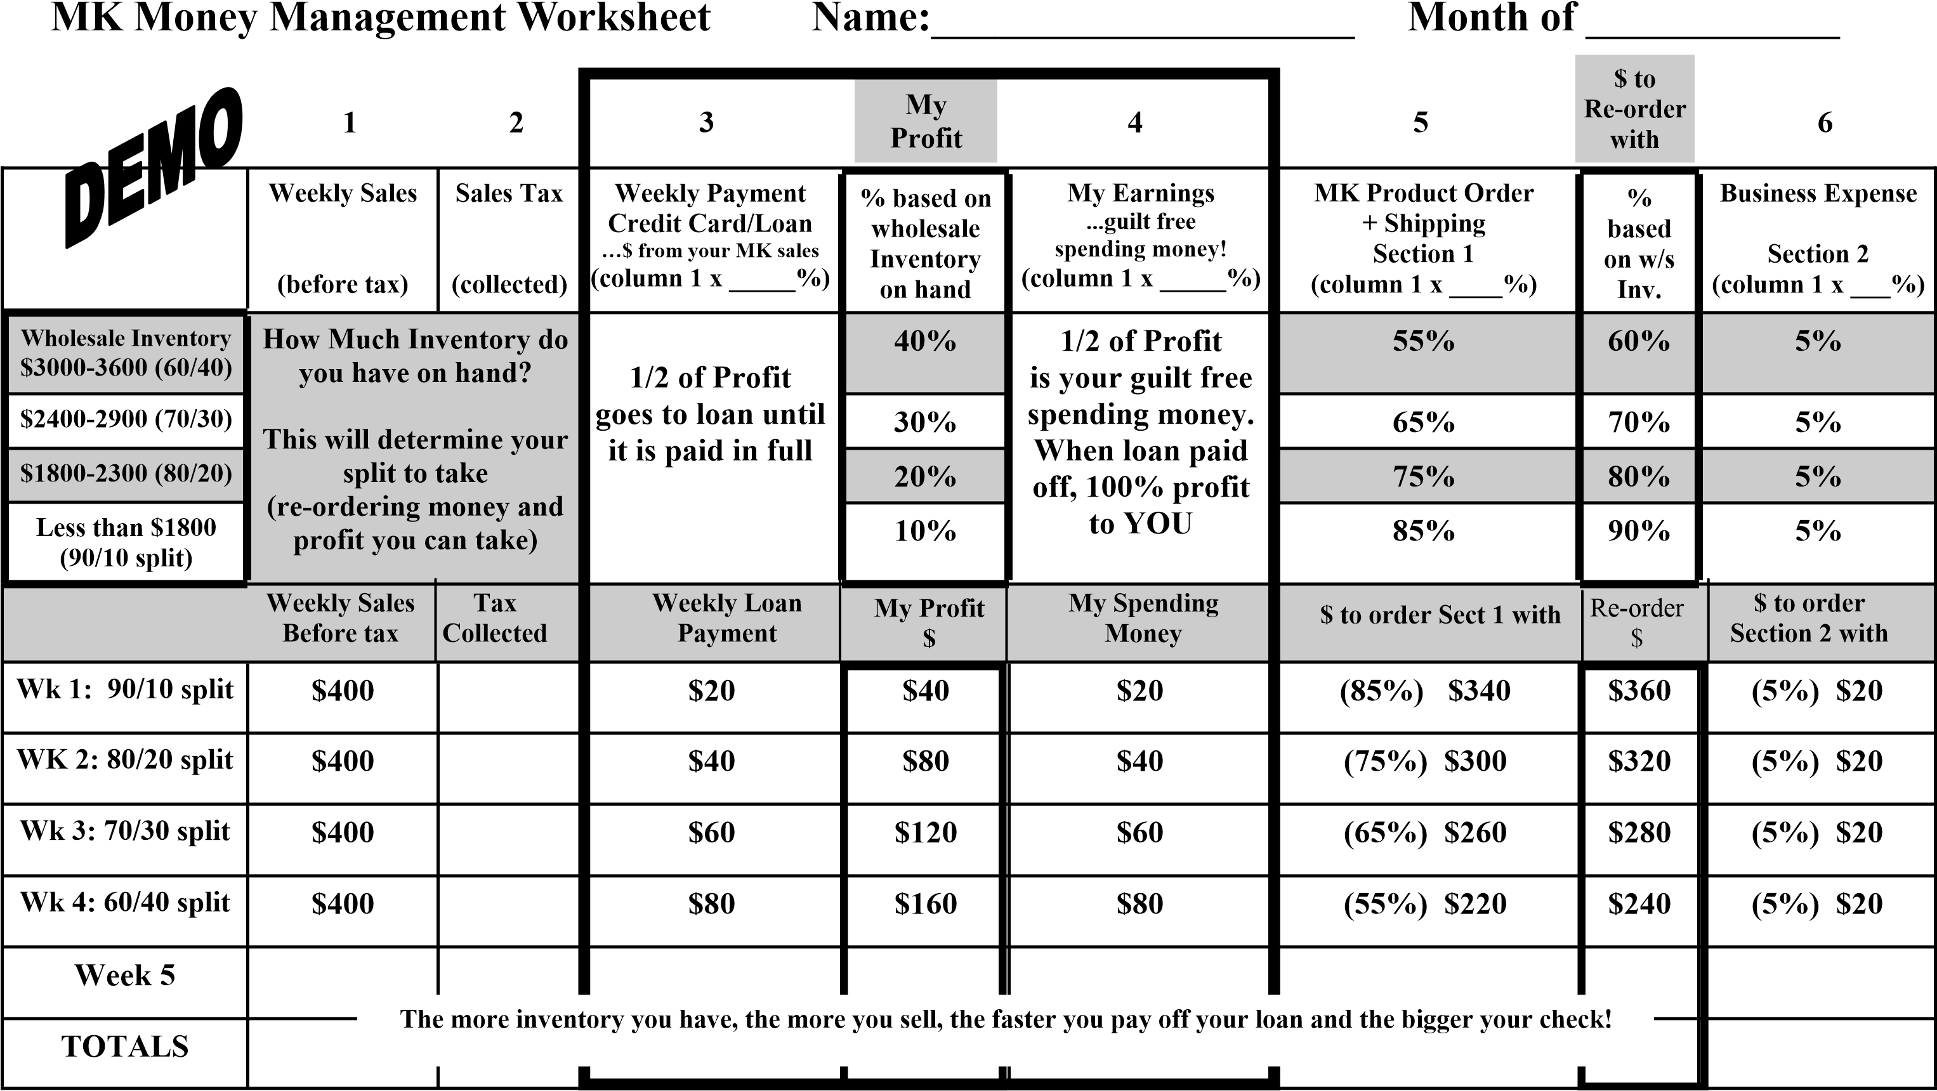

**YOU MUST RUN YOUR MONEY RIGHT!** *More women have failed in their business because they didn’t* ***respect the money system****!*

1. Get your inventory on a **PROFIT LEVEL** ($3600 w/s)! (this allows you to pay yourself PLUS you are able to pay off your MK loan more quickly)
2. Complete this Money Management Worksheet and the Weekly Summary Sheet **EVERY WEEK**! (watch your profits & sales soar!)
3. **CONSISTENCY** is the key to success! **MAKE IT A HABIT**!
4. **EVERY WEEK**….**MAKE YOUR PAYMENT** to your loan or credit card because interest is compounded daily!!!
5. **EVERY MONTH...PLACE YOUR WHOLESALE PRODUCT ORDER**!!! Order smart ($400-$600**) $600+/mo. tracks for Star Consultant!**
6. **EVERY WEEK...WRITE YOURSELF A PAYCHECK**!!! (the more inventory you have on hand, the more profit you are able to take right away!)

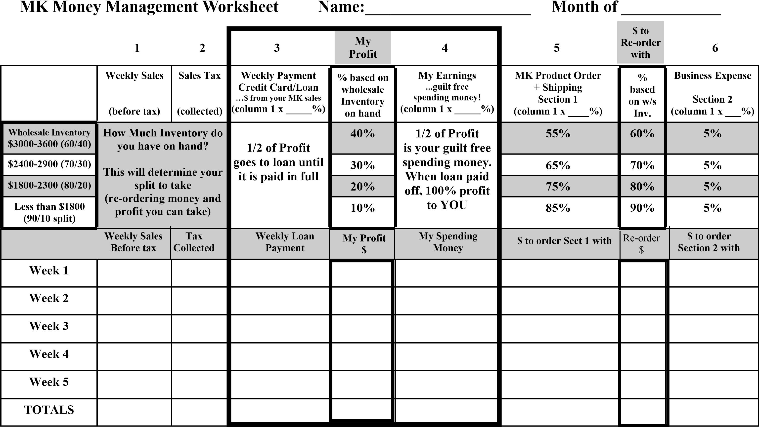

**YOU MUST RUN YOUR MONEY RIGHT!** *More women have failed in their business because they didn’t* ***respect the money system****!*

1. Get your inventory on a **PROFIT LEVEL** ($3600 w/s)! (this allows you to pay yourself PLUS you are able to pay off your MK loan more quickly)
2. Complete this Money Management Worksheet and the Weekly Summary Sheet **EVERY WEEK**! (watch your profits & sales soar!)
3. **CONSISTENCY** is the key to success**! MAKE IT A HABIT**!
4. **EVERY WEEK**….**MAKE YOUR PAYMENT** to your loan or credit card because interest is compounded daily!!!
5. **EVERY MONTH...PLACE YOUR WHOLESALE PRODUCT ORDER**!!! Order smart ($400-$600**) $600+/mo. tracks for Star Consultant!**
6. **EVERY WEEK...WRITE YOURSELF A PAYCHECK**!!! (the more inventory you have on hand, the more profit you are able to take right away!)